^{ONLINE PAYMENT FRAUD DETECTION}
MENTOR:SRI L.LAKSHMI NARAYANA
TEAMID:LTVIP2026TMIDS46417
TEAM LEADER:VAIBOYINA DEVI
Roll number:SBAP0040409 MAIL ID:deviyaiboina@gmail.com
TEAM MEMBERS:
1)MARIPI SAI
Roll number:SBAP0040476 MAIL ID:saimaripi3@gmail.com
2)SAPPA KIRANMAI
Roll number:SBAP0040479 MAIL ID:kiransappa5@gmail.com
3)YELETI SUDHARANI
Roll number:SBAP0040406 MAIL ID:yeletisudharani08@gmail.com
^{INTRODUCTION TO AIML}
^{Artificial Intelligence (AI)}
AI refers to the simulation of human intelligence by machines. It enables computers and systems to perform tasks that typically require human intelligence, such as:
^{• Learning}
^{• Reasoning}
^{• Problem-solving}
^{• Understanding language}
^{• Perception}
^{Types of AI:}
1. Narrow AI: Focused on a specific task (e.g., Siri, Google Maps).
2. General AI: Human-level cognitive abilities (still theoretical)
3. Super AI: Exceeds human intelligence (not yet developed Machine Learning (ML)
ML is a subset of AI that enables machines to learn from data and improve their performance over time without being explicitly programmed.
^{Types of ML:}
- Supervised Learning: Uses labeled data.
o Examples: Regression, Classification
2. Unsupervised Learning: Uses unable data
o Examples: Clustering, Association
3. Reinforcement Learning: Learning by trial and error with feedback.
o Example: Game playing bots, self-driving cars
^{Deep Learning (DL)}
A subset of ML that uses neural networks with multiple layers (like the human brain) to analyz data and make decisions.
• Common in image processing, speech recognition, etc.
^{• Tools: TensorFlow, pytorch}
What is Machine Learning? Machine Learning is a branch of Artificial Intelligence (AI) that allows computers to learn from data and make decisions or predictions without being explicitly programmed.
^{In simple words:}
"ML teaches machines to learn from experience (data), just like humans learn from practice."
^{How Machine Learning Works}
1. Collect Data – Historical data (e.g., past sales, weather data)
2. Train a Model – Use algorithms to learn patterns from the data
3. Make Predictions – Apply the model to new, unseen data
4. Evaluate Accuracy – Check how well the model performs
^{Types of Machine Learning}
Type Description Example
✅Supervised Learning Learn from labelled data Email spam detection
Unsupervised Learning Find hidden patterns customer segmentation Reinforcement Learning Learn by trial & error with feedback Self-driving cars
^{Common Algorithms}
Algorithm Use Case
Linear Regression Predicting prices/sales
Decision Trees Making logical decisions
K-Nearest Neighbors Pattern recognition
Support Vector Machines Classification problems
K-Means Clustering Grouping similar data
Random Forest Complex predictions

ONLINE PAYMENT FRAUD DETECTION:
As we are approaching modernity, the trend of paying online is increasing tremendously. It is very beneficial for the buyer to pay online as it saves time, and solves the problem of free money. Also, we do not need to carry cash with us. But we all know that Good thing are accompanied by bad things.
The online payment method leads to fraud that can happen using any payment app. That is why Online Payment Fraud Detection is very important.
^{TSK:732075}
^{1)DATA COllECTION:}
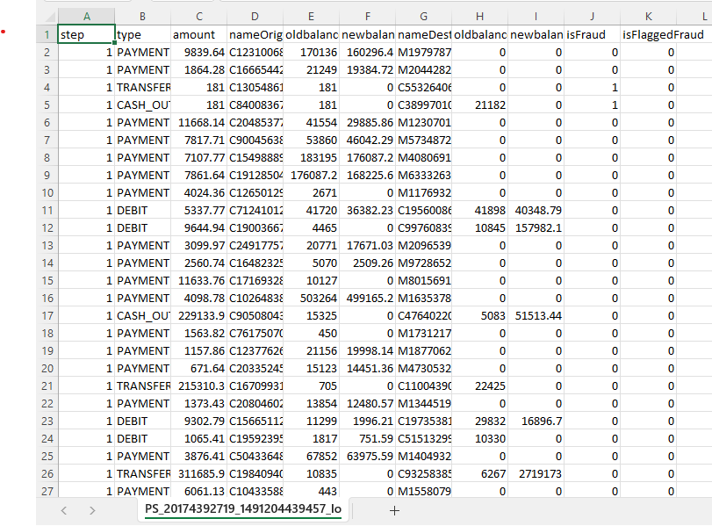

^{TSK:732076}
^{Visualizing and analyzing data}
^{IMPORTING LIBRARIES}
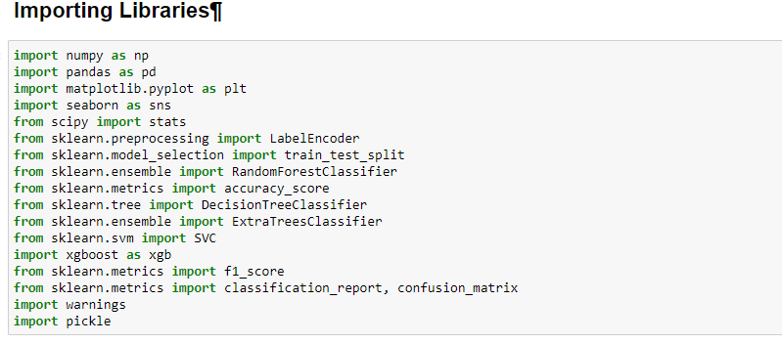
^{TSK:732077}
^{Read the dataset}
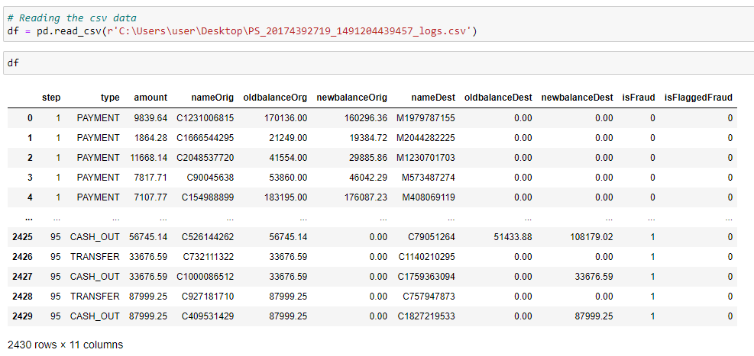
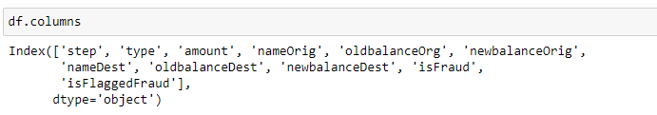
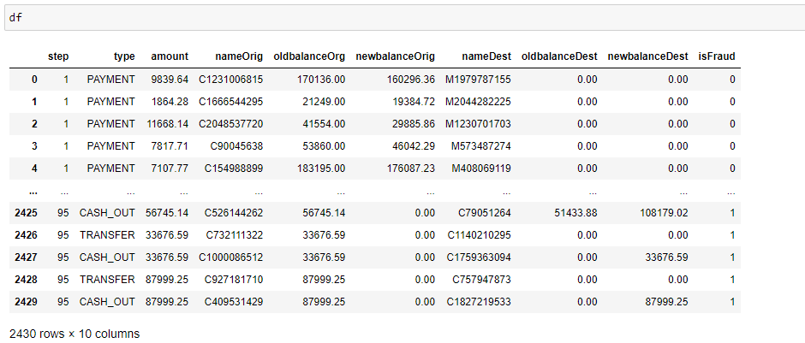
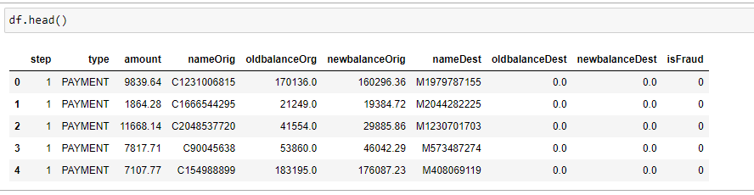
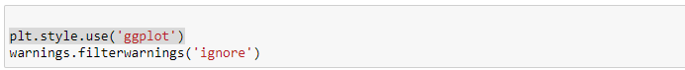
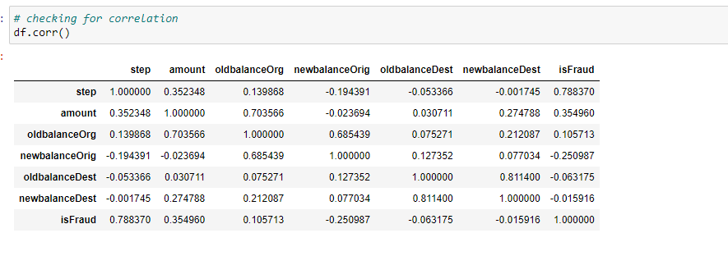
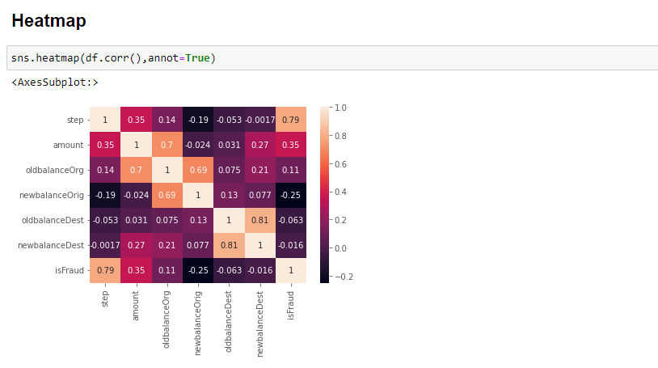
TSK:732078
Univariate analysis
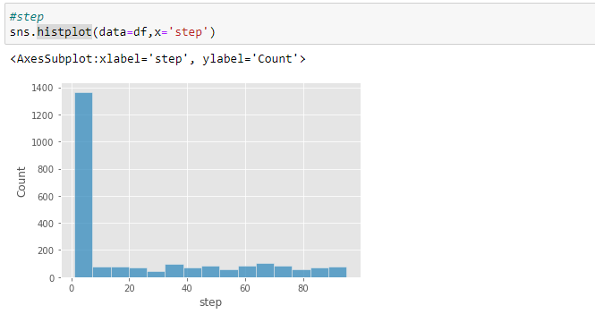

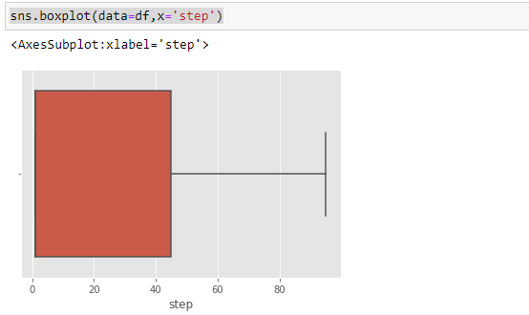
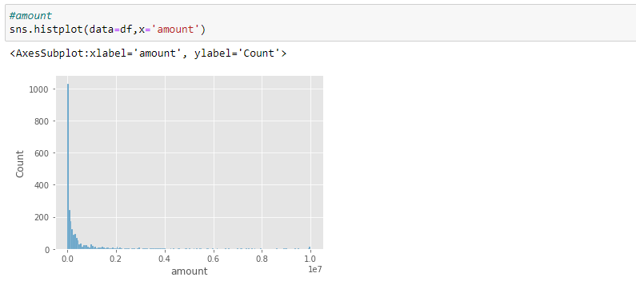
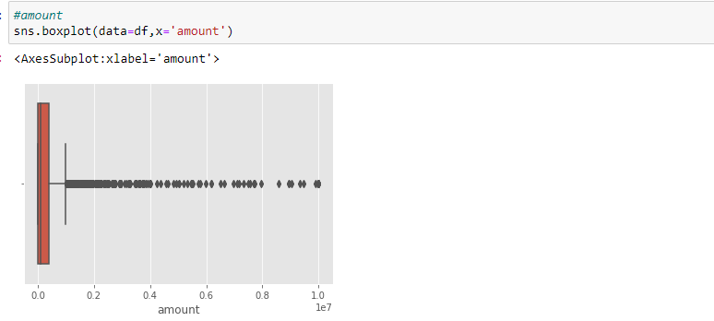

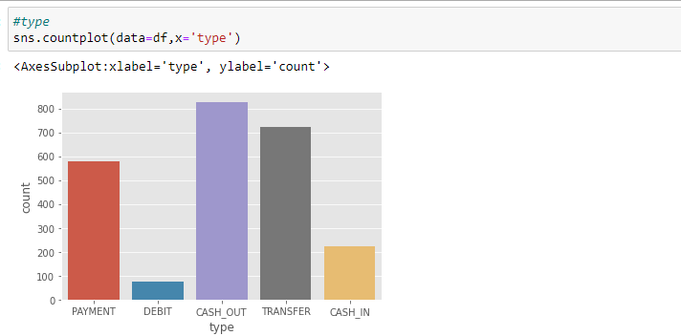
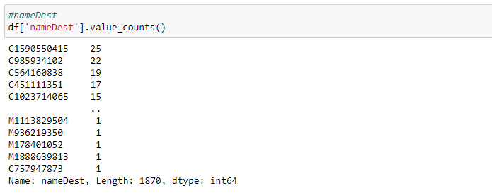
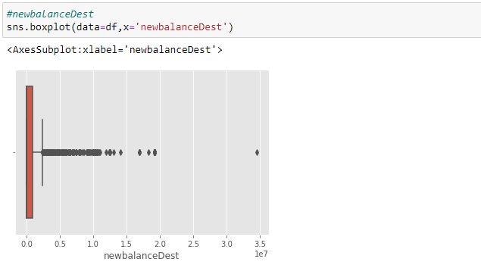
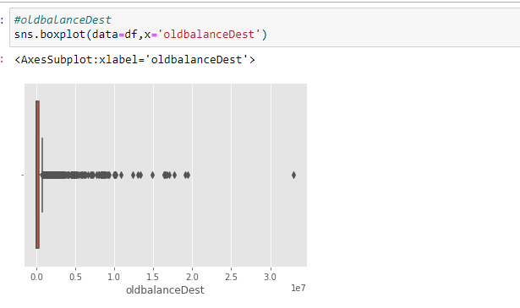
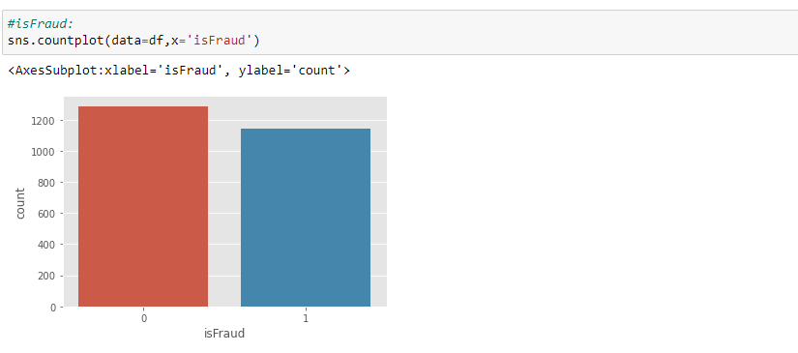
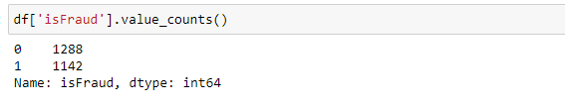

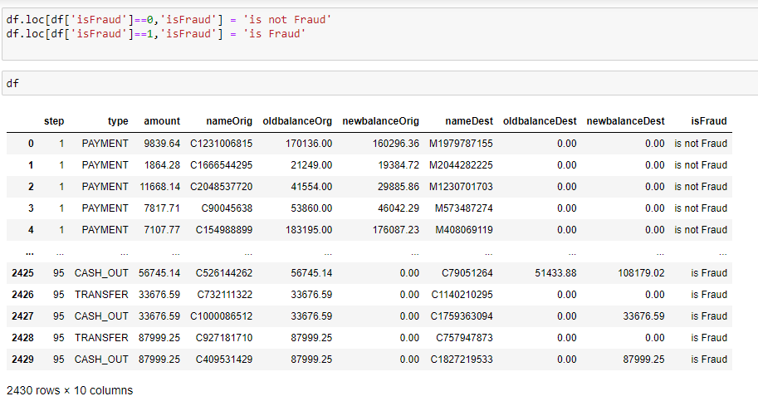
TSK:732079
Bivariate analysis
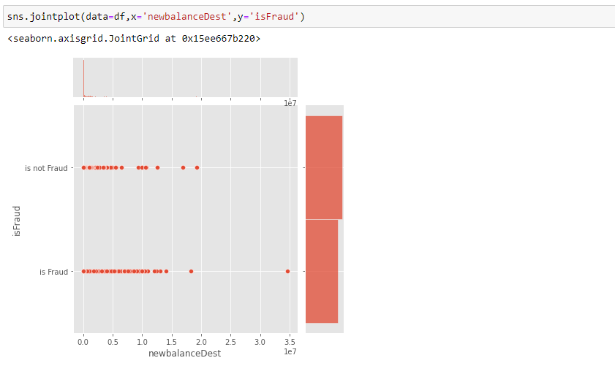

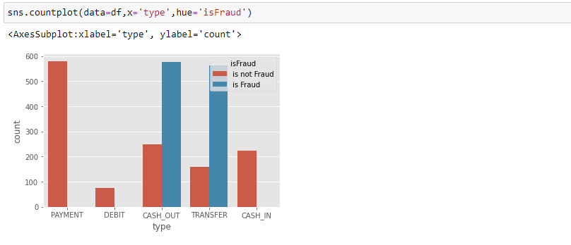
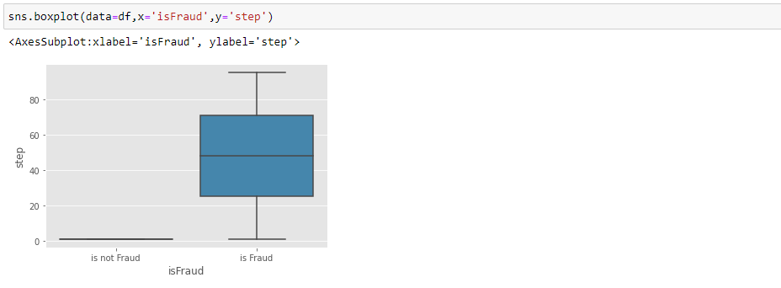
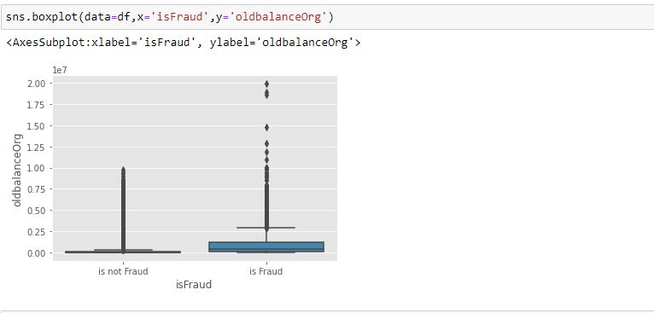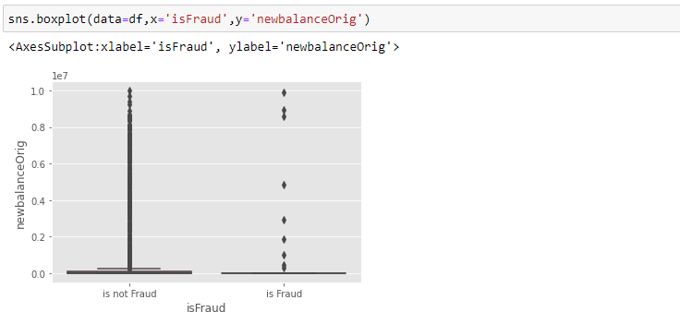

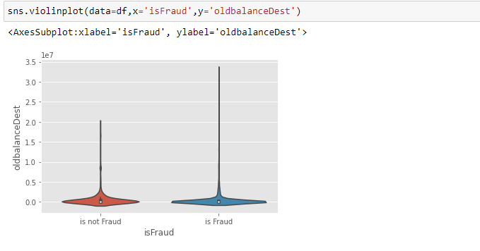
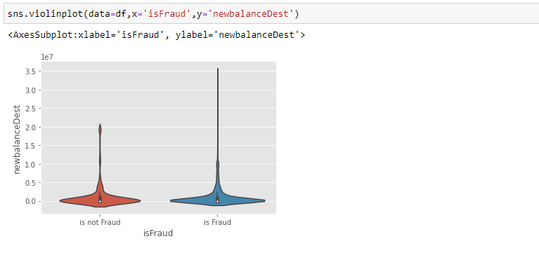
TSK:732080
Descriptive analysis
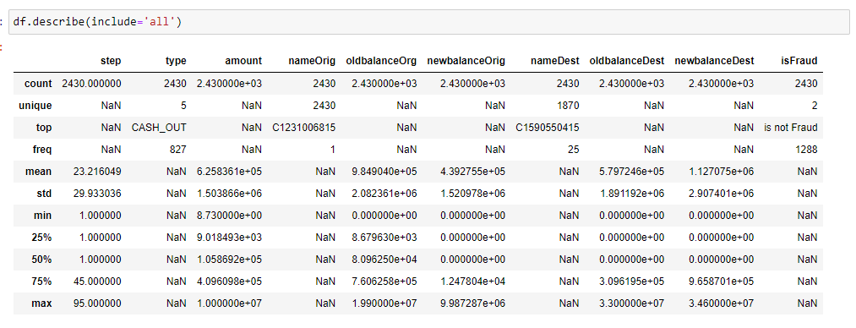
Data Pre-processing
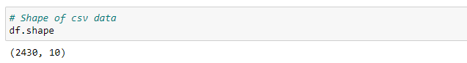
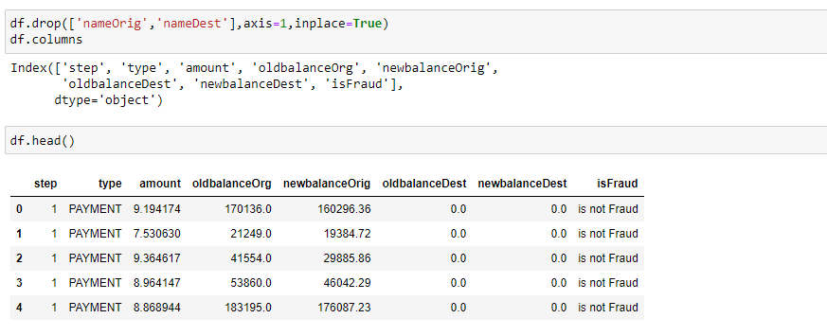
TSK:732081
Checking for null values
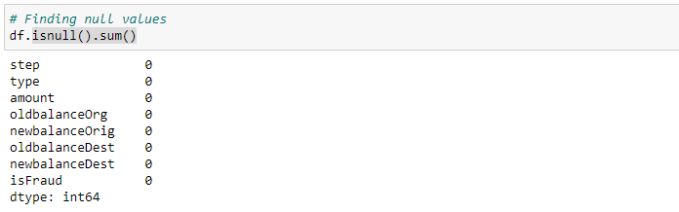
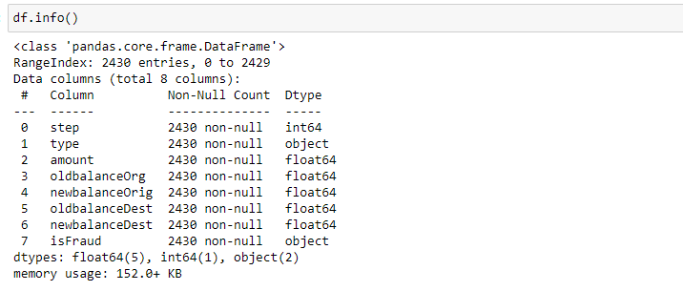
TSK:732082
Handling outliers
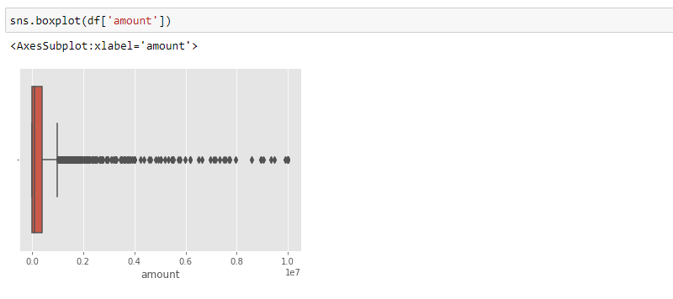
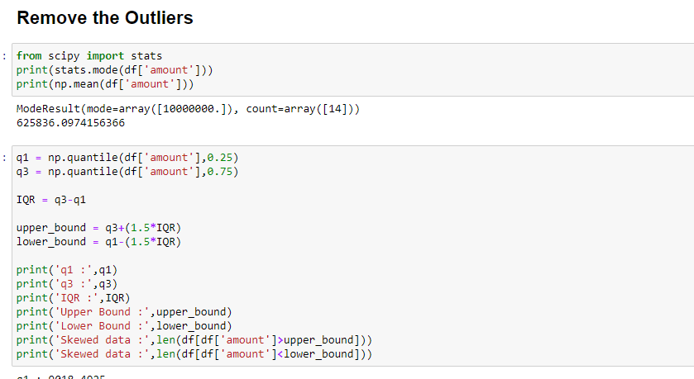

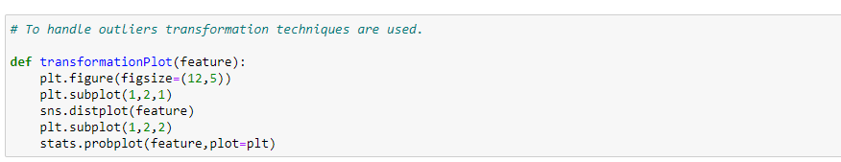

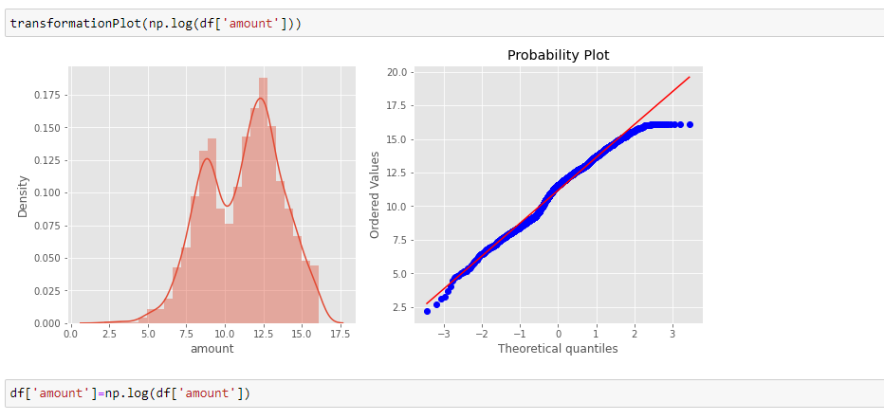
TSK:732083
Object data label encoding
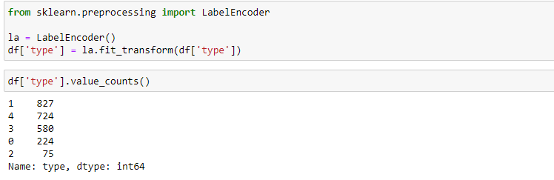
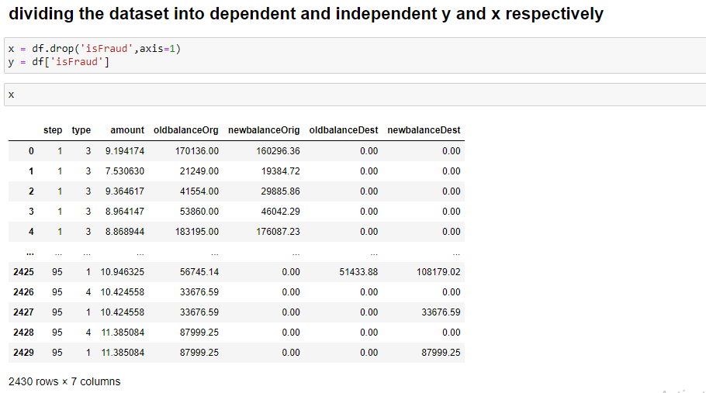
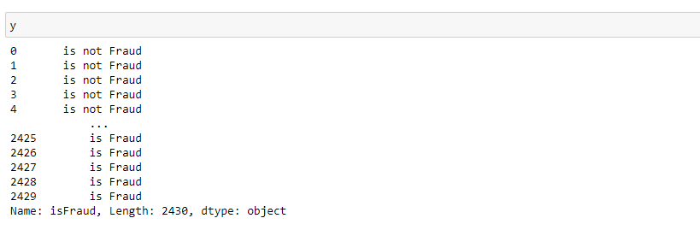
TSK:732084
Splitting data into train and test
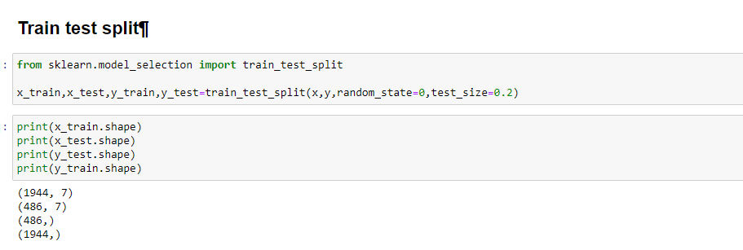
Model Building
Now our data is cleaned and it’s time to build the model. We can train our data on different algorithms. For this project we are applying four classification algorithms. The best model is saved based on its performance.
TSK:732085
Random Forest classifier
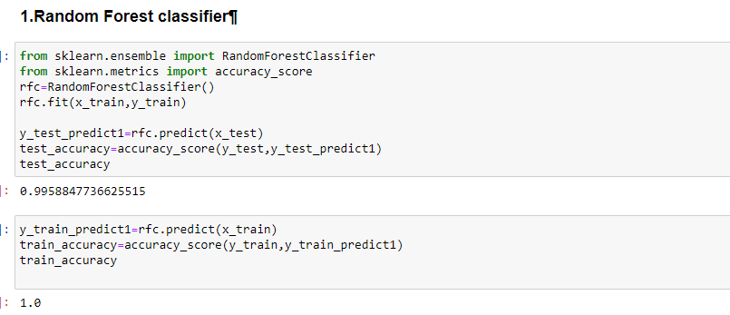

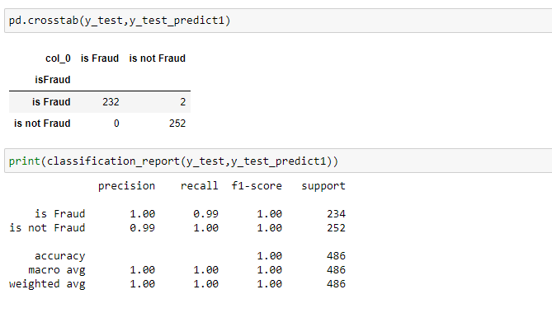
TSK:732086
Decision tree Classifier
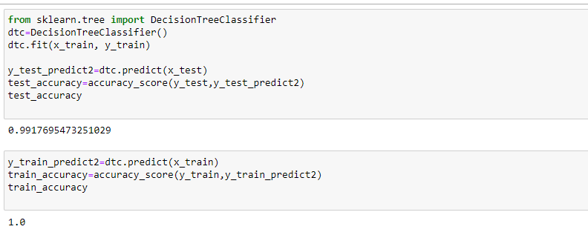
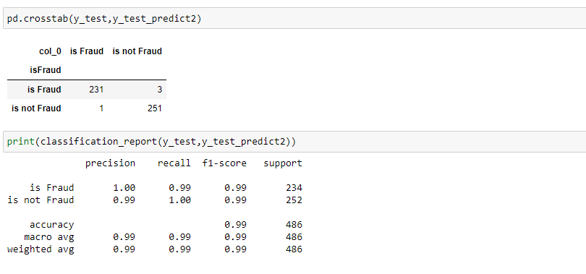
TSK:732087
Extra Trees Classifier
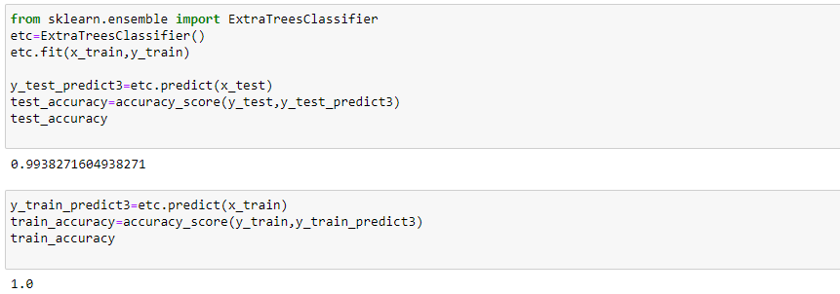
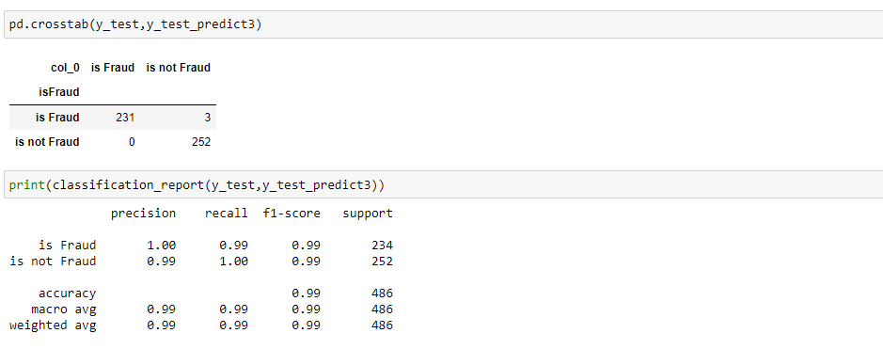
TSK:732088
Support Vector Machine Classifier
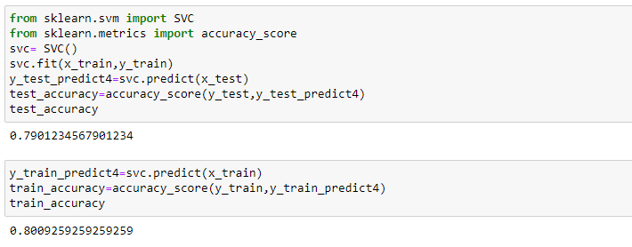
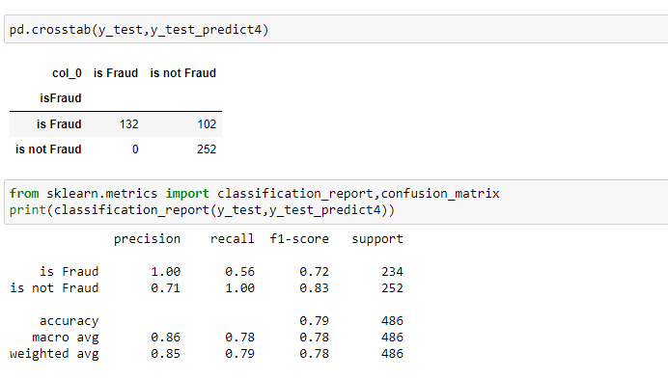
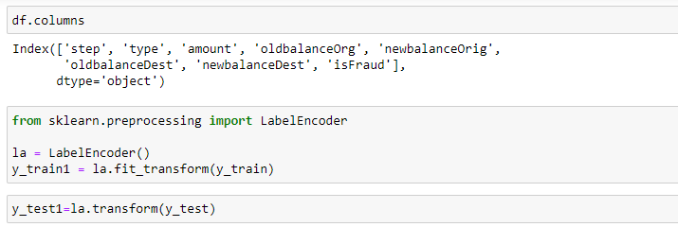
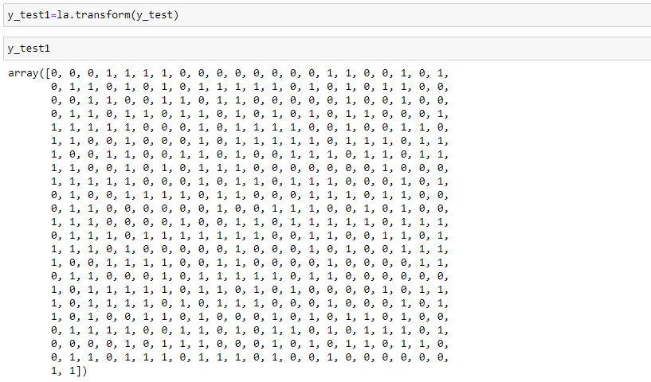

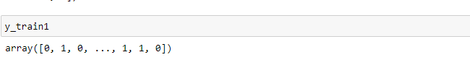
TSK:732089
X g boost Classifier
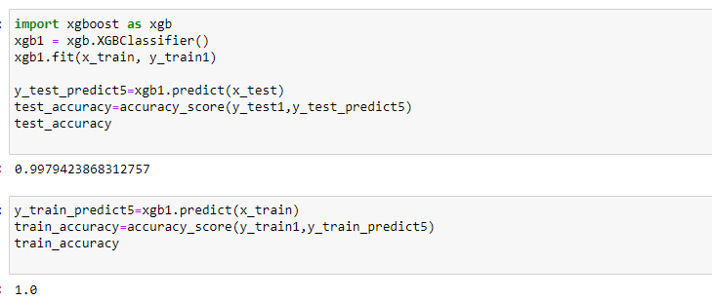

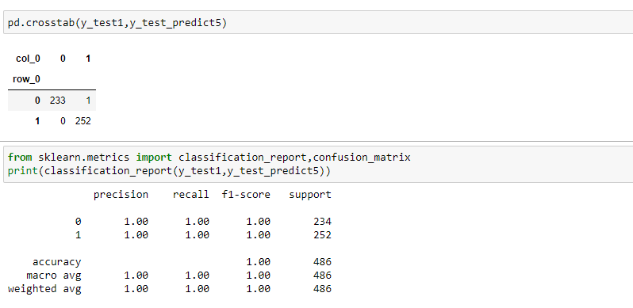

TSK:732090
Compare the models
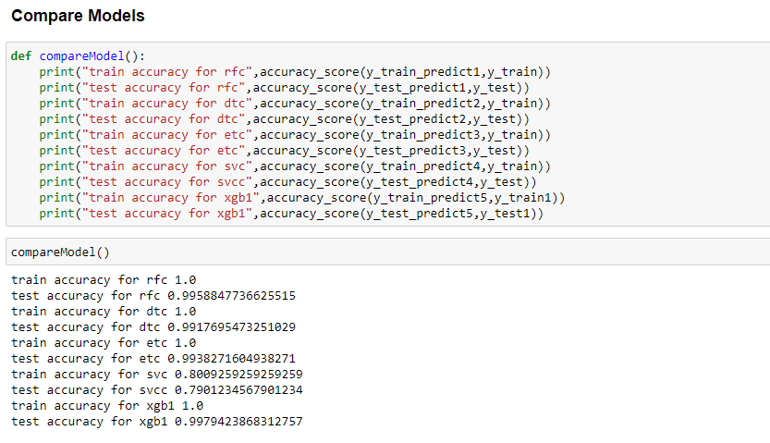
TSK:732091
Evaluating performance of the model and saving the model
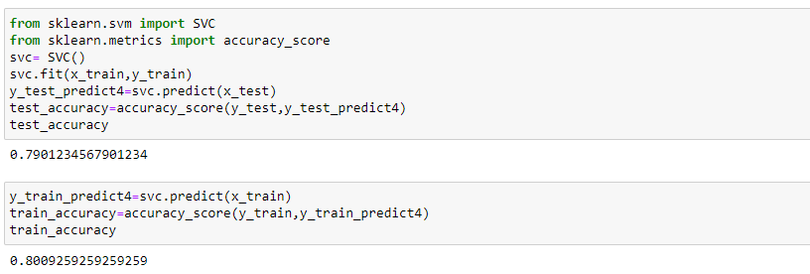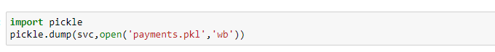
TSK:732092
Building Html Pages:
- home.html
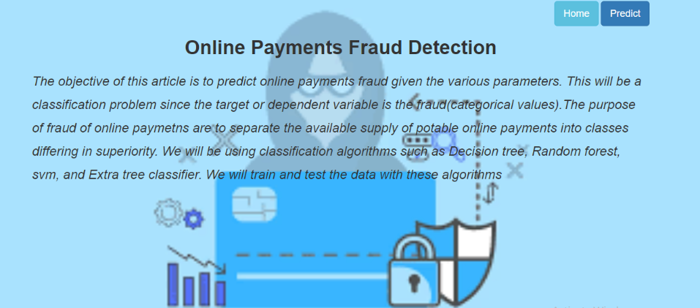
- predict.html
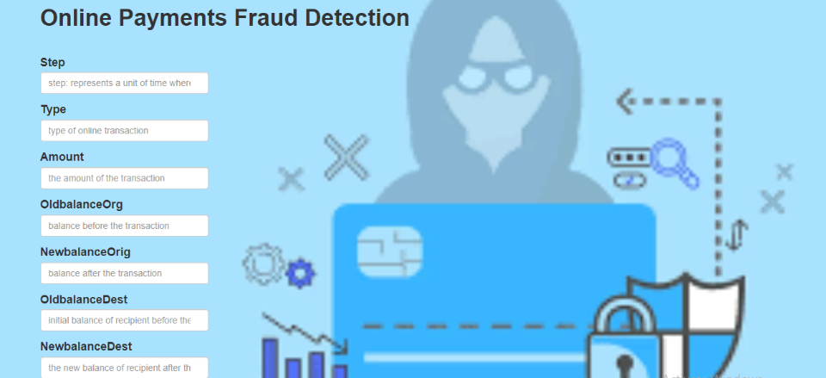
- submit.html
- 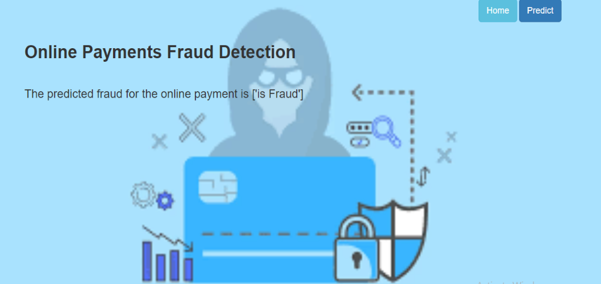
- TSK:732093
- Build Python code
- 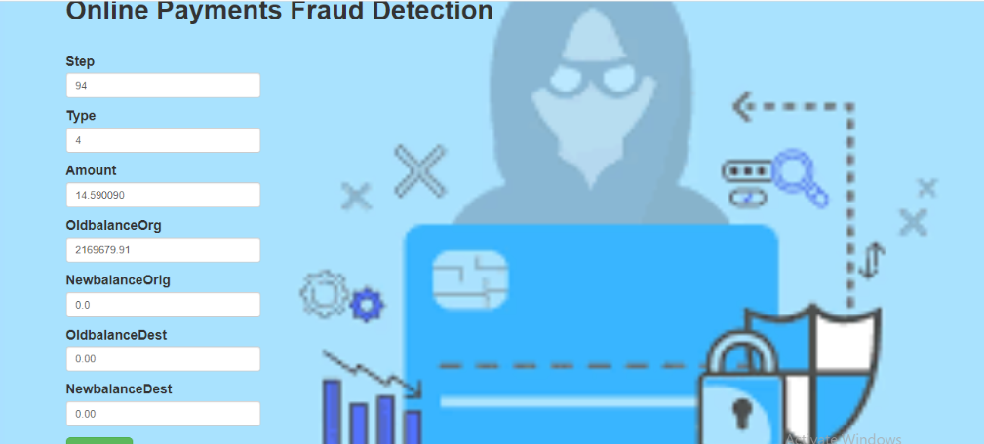

- TSK:732094
Run the application
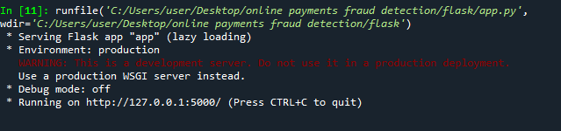
OUTPUTS:
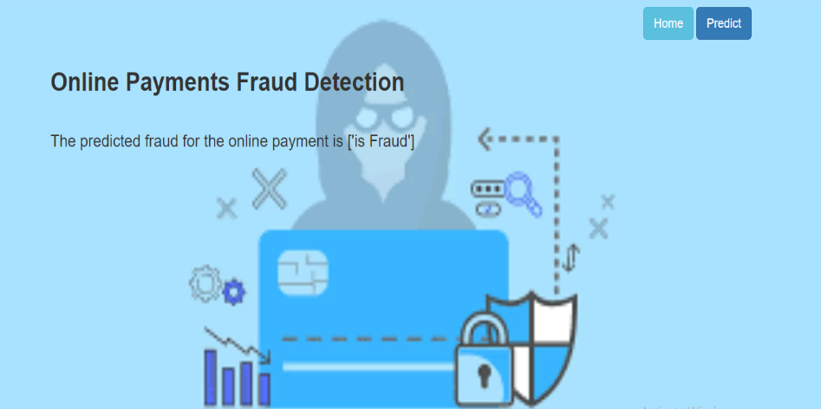
COMMENTS:
I have learnt so many concepts about AIML (Artificial intelligence & Machine Learning) me and my team can learn how to tackle do it DATA by Machine Learning and it is very interesting to do it in step to step and finally in project we will do it project.
___VAIBOYINA DEVI
Team Leader
THE END

